eBay Fees and costs to seller
Selling on eBay - how to avoid fee erosion
GFG McMullon


CONTENTS
1 Selling on eBay - how to avoid fee erosion 3
1.1 Links 3
2 fees and charges 4
2.1 Ebay selling fees 4
2.2 For Private Sellers 4
2.3 For Business Sellers 6
2.4 Maximum charges restriction on postage 8
2.5 Fee Calculator 12
2.6 Postage issues 14
2.7 Royal Mail Prices 14
2.8 Size and weight restrictions for Royal Mail Postage 16
2.9 Royal Mail Price finder 16
2.10 Parcel Force Price finder 18
2.11 Parcel2Go 18
2.12 PayPal Fees 19

- Selling on eBay - how to avoid fee erosion
eBay encourages sellers to list items for 99p with free postage. They claim that this encourages bidding for people hoping to get a bargain. This is true for many items for which there is a demand and above a certain value but leads the seller open to fees and postage costs that exceed the value of the sale.
eBay also changes the fees, the limits on quoted postage costs and the way fees are applied. Royal Mail have a special offer on parcels up to 2kg until January so expect 1-2kg parcel costs to rise.
  - Links
Seller’s fees http://sellercentre.ebay.co.uk/selling-fees
Business Seller’s fees http://sellercentre.ebay.co.uk/fees-business-sellers-0
eBay Maximum charges on postage http://pages.ebay.co.uk/help/sell/maximumPP_FAQ.html#maxcosts
eBay Fee calculator http://www.fees.ebay.co.uk/feeweb/feecalculator
Royal Mail Prices (changes in January 2015)
http://www.royalmail.com/sites/default/files/RM-Our-prices-20-October-2014.pdf
Royal Mail prices calculator
http://www.royalmail.com/price-finder
PayPal fees https://www.paypal.com/uk/webapps/mpp/paypal-fees and look for Selling with PayPal
- fees and charges
  - Ebay selling fees
http://sellercentre.ebay.co.uk/selling-fees
  - For Private Sellers
Private sellers have a simple set of fees but still with hidden problems.
Free insertion fees for first 20 listings
10% final value fees on the total of final value and postage costs
3.4% + 20p basic PayPal fees, 5-8% if cross boarder payments
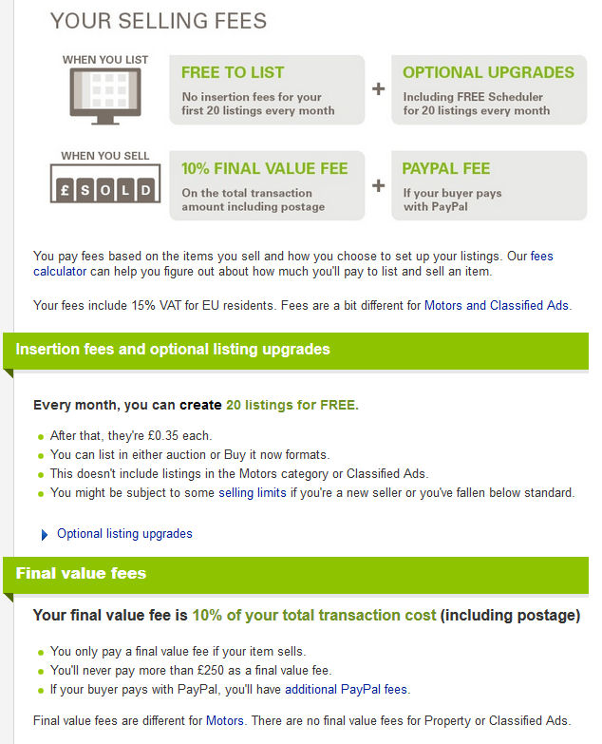
Listing upgrades include free addition pictures and super size images at an extra cost of £2.50. This many help for a swift sale but cost every time you relist.
If you offer collection (no postal charges) then the buyer can book their own collect and deliver service or collect themselves. Useful for heavy, expensive or bulky items but limits potential buyers i.e. excludes overseas buyers.
  - For Business Sellers
Business sellers are not necessarily a business. If you are decluttering you soon can reach the numbers when eBay decide you are a business. A charity or business may be VAT registered which means the VAT is excluded on fees so you keep more of your gains but have to charge it on most items including postage.
As eBay is based in Luxembourg the VAT charged is 15%.
The fees for business sellers are more complex with different rates depending where you list the item for sale.
http://sellercentre.ebay.co.uk/fees-business-sellers-0
Business sellers are charged 11% but in some categories less, even half at 5% and a maximum charge of only £10.
. 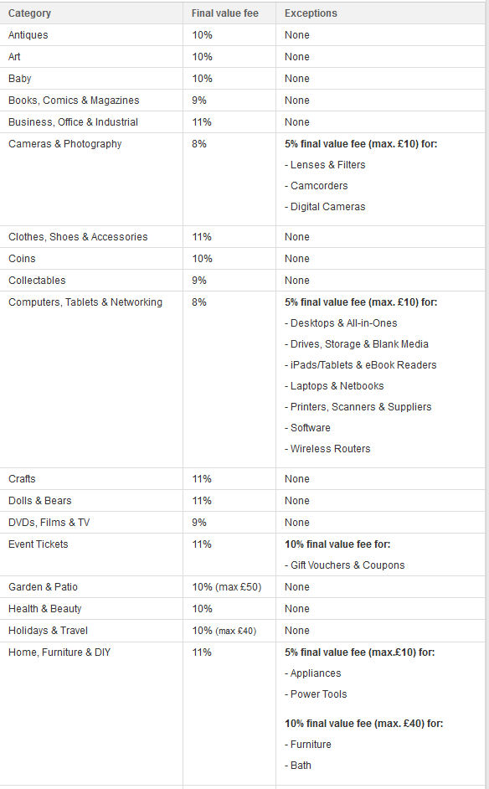
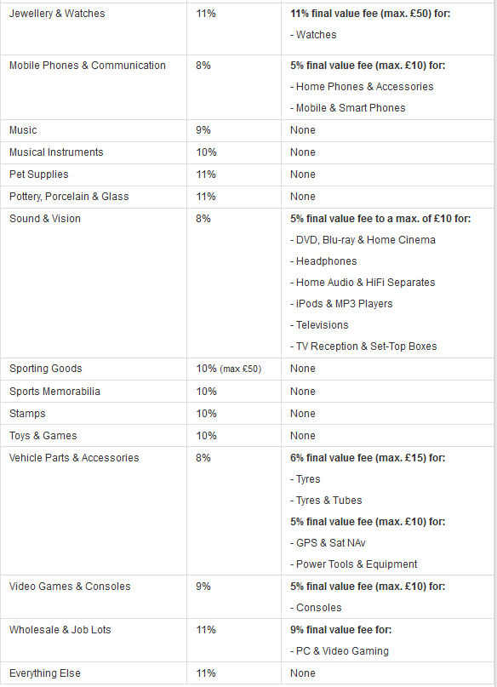
  - Maximum charges restriction on postage
There are also maximum limits on the postage you are allowed to include for domestic sales. This applies to both private and business sellers.
This particularly affects heavy books, boxes of CDs or DVDs, even landline digital phones with base stations. Many low value items are heavy or bulky costing excessive postal charges and a cap on what eBay allow you to charge.
http://pages.ebay.co.uk/help/sell/maximumPP_FAQ.html#maxcosts
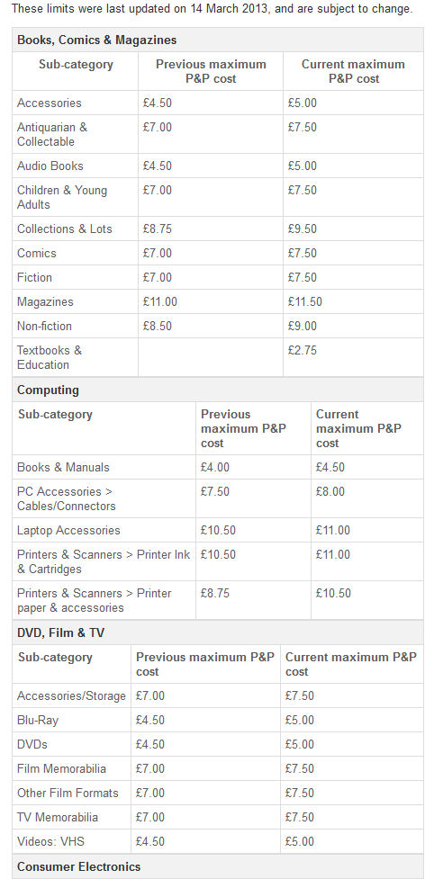
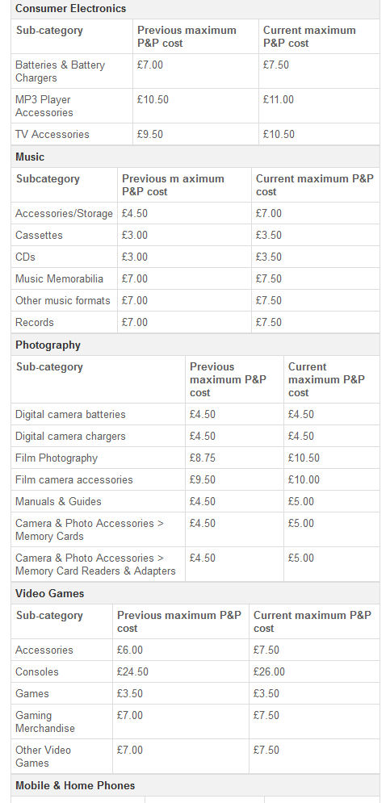
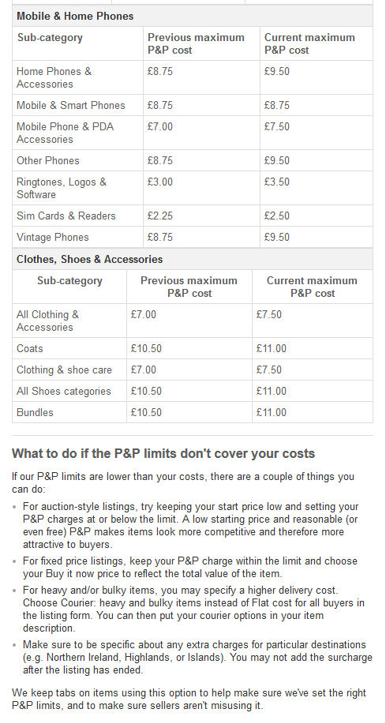
One way to cover this cap is to allow the buyer to collect or book their own collection and delivery. This removes the limit, avoids fees and the buyer takes the risk on signed for, tracking you just have to package it for free.
The other option is to specify bulky items in the postage and details in the description on choices. This means the buyer can not automatically complete payment and check out and may pay for the postage later when invoiced adding another transaction charge onto the costs – only 20p.
  - Fee Calculator
Use the Seller type of Private or Business with and without VAT charges to see the change on fees. Listing upgrades become expense options unless they really help make the sale.
http://www.fees.ebay.co.uk/feeweb/feecalculator
Sellers have to quote a fixed postage cost, at least to UK buyers. This means you need to know the package weight, size and cost.
The postage needs to include at least its only coverage of fees – 10% for a private seller, 3.4% for PayPal. This adds 11.55% to the postage costs.
Example
If the postage is £10 and you charge the buyer £11.55
Postage at the Post Office £10
eBay fee on Postage of £11.55 £ 1.16
PayPal fee on the postage amount 3.4% £0.39
Total costs £11.55
The short cut to this calculation is
Postage at the Post Office = Postage at the Post Office
(1 – 10% - 3.4%) 0.866
The fee of 20p charge by PayPal is covered (we hope) in the final value of the item sold.
As seen in the following examples, using the fee calculator, the fees for postage costs are not provided even though it offers two slots for postage costs. In listing on eBay there are several postage options to each of UK, EU, North America and the rest of the World.

    - Private seller selecting Personal CD category
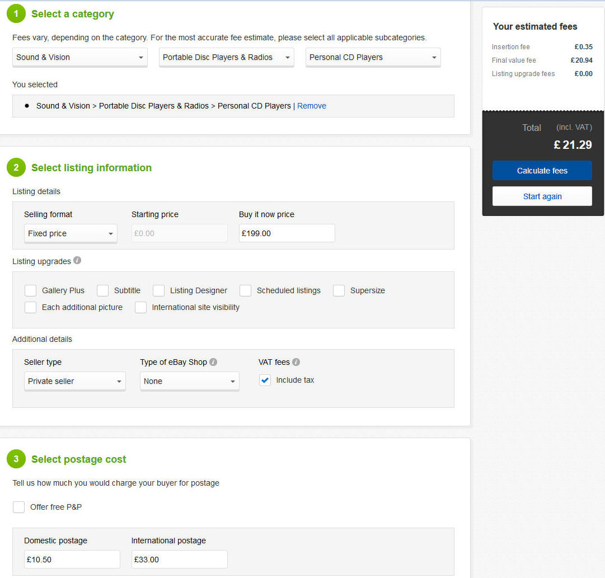
    - Business seller selecting Personal CD category
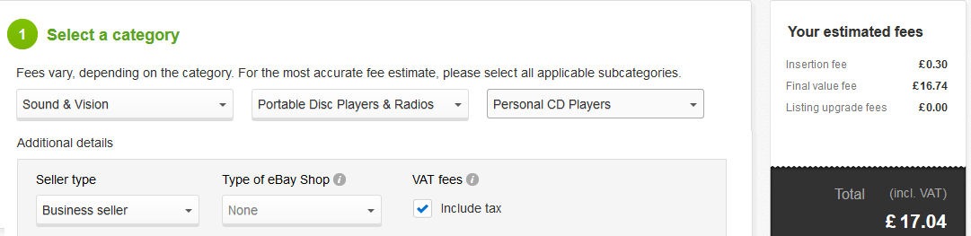
    - Business seller selecting Hi-fi separates CD player category
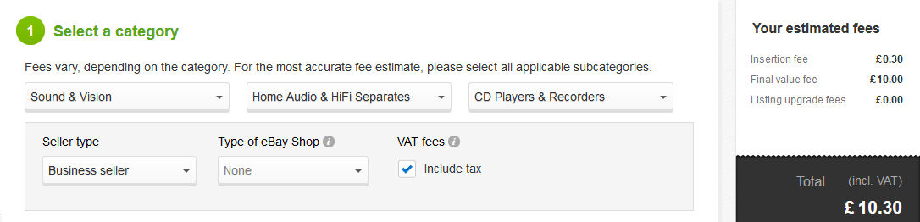
    - Business seller selecting Hi-fi separates CD player category excluding VAT
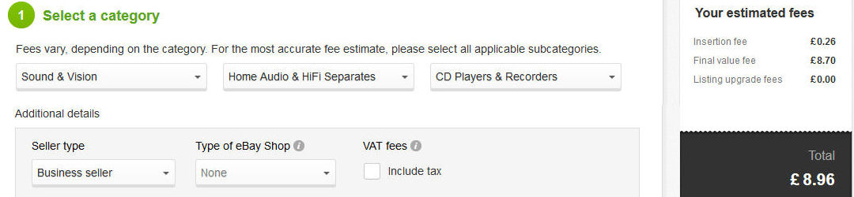
  - Postage issues
eBay requires sellers to list a fixed price for postage costs and for each location you will send to (UK, EU & Europe, North America and the rest of the World). You can offer postage world wide without quoting a price but covering costs in the details or by e-mails. However the overseas buyer then is unable to complete check out until you invoice them. This may not be an issue, but the high costs of even small parcels can result in you having to cancel the sale.
To prevent excessive postage costs eBay put a limit on the amount charged for some categories. This covers a CD, DVD, a paper back book but not a CD box set, a DVD series or a heavy reference book. Adding to that eBay require all parcels to be tracked. This requires special delivery. Insurance through signed for and special delivery also adds to the basic postage cost – which the limit may exclude except as a second option. If the buyer choose basic postage, no tracking or insurance, then failure to deliver results in a charge back and non-recovery of the lost from the postal service.
There is no restriction on the charges applied to posting outside of the UK. The charges for parcels have risen steeply in the past few years making posting of even small packages too expensive.
  - Royal Mail Prices
Prices for parcels now include size and weight restrictions. Parcel Force also use a volumetric calculation for overseas parcels and charge the higher number of that or the real weight.
http://www.royalmail.com/sites/default/files/RM-Our-prices-20-October-2014.pdf
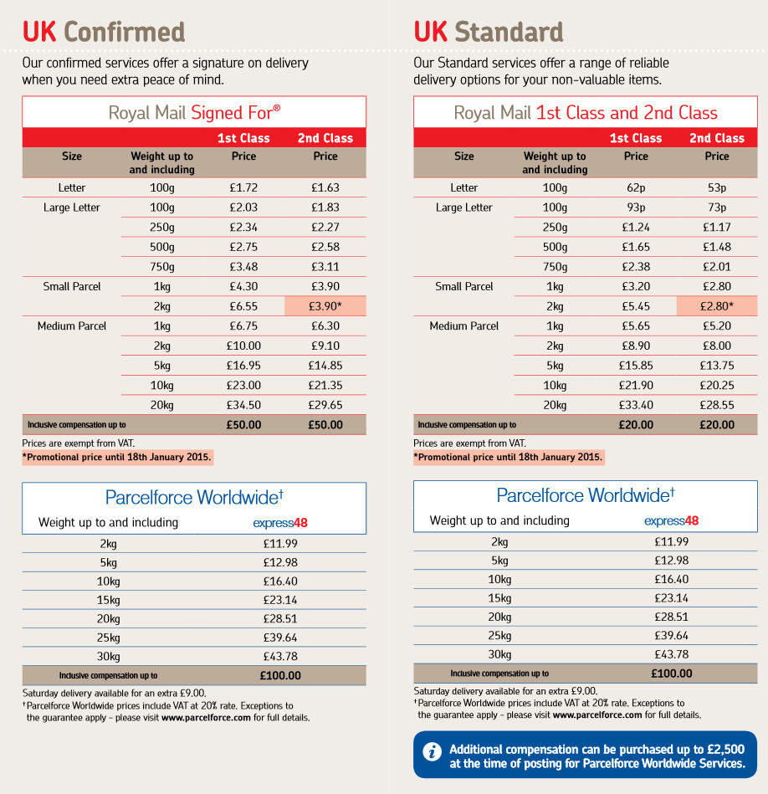
  - Size and weight restrictions for Royal Mail Postage
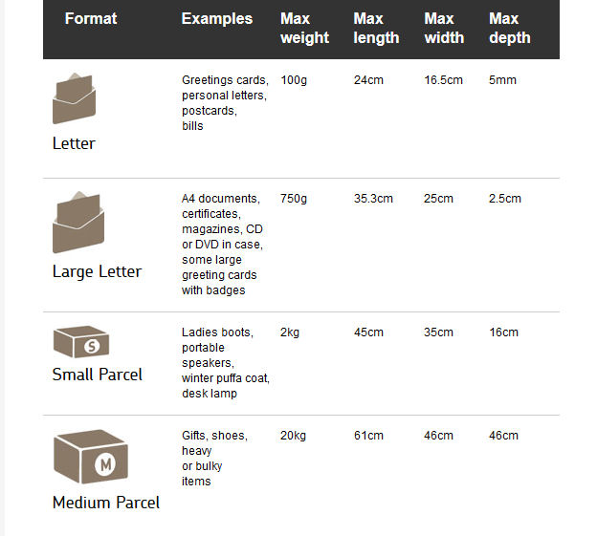
The volumetric charge for overseas parcels is calculated as length x width x height (in cm) divided by 5000.
so an item weighing 8Kg in a box 30x40x50 cm is 30x40x50/5000 = 12kg, so the higher weight is used.
The online calculator works this out for you.
  - Royal Mail Price finder
http://www.royalmail.com/price-finder
Although Royal Mail include calculations for packages sent by Parcel Force their price calculator differs from the one found on Parcel Force web site. If you pay online and take to the local Post Office that Post Office gets nothing for the service and if everyone did that they would have no income!
Examples shown below are for a 2kg parcel in the UK and being sent to China.
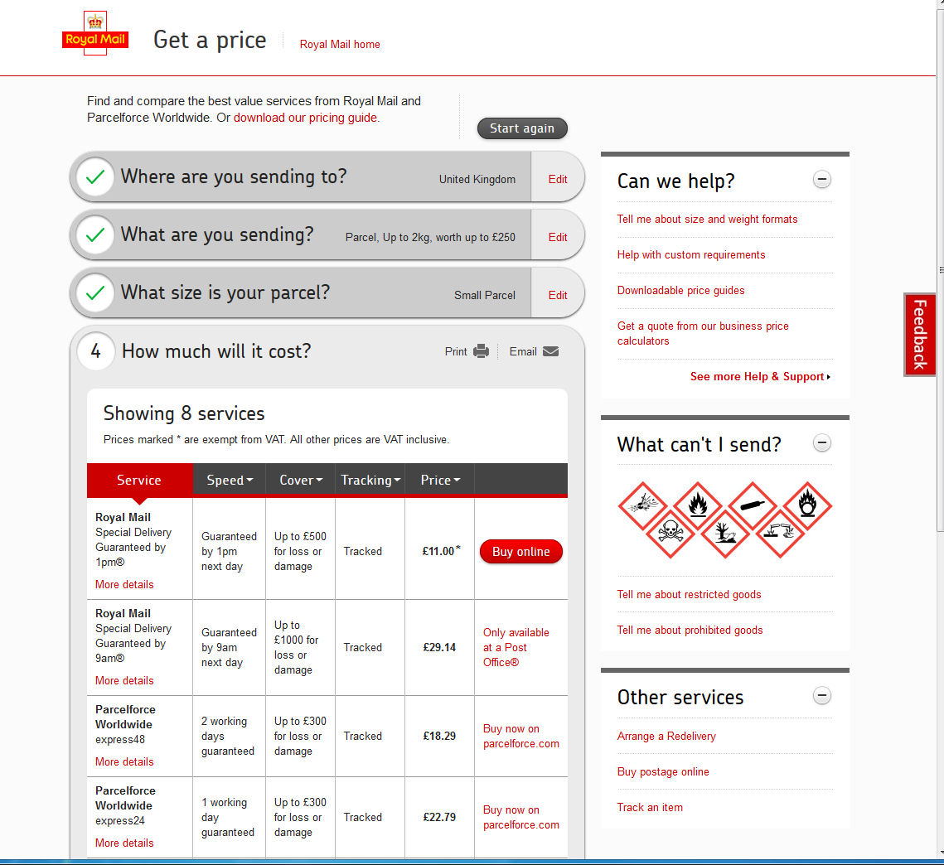
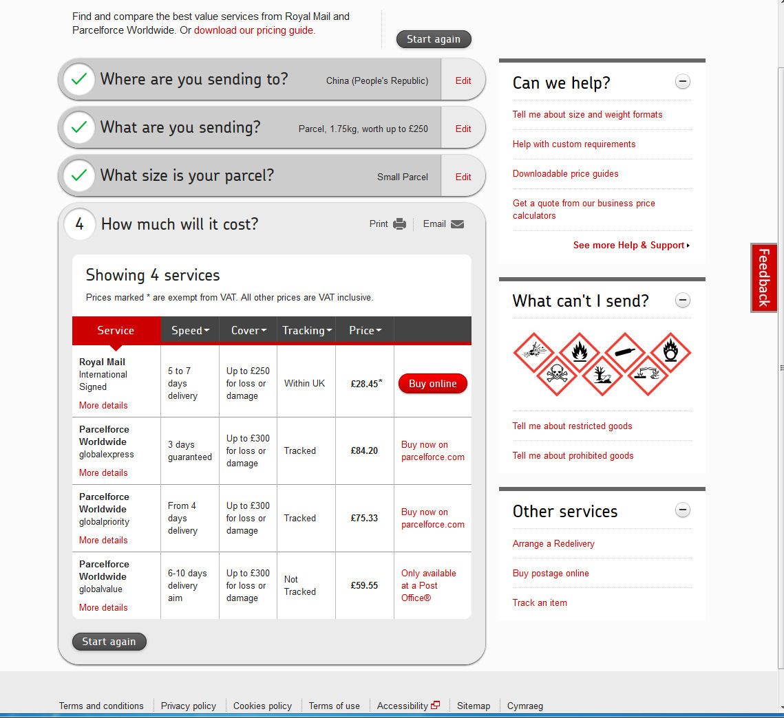
  - Parcel Force Price finder
http://www.parcelforce.com/price-finder
Parcel Force have their own price finder which differs in the quote as seen on the Royal Mail quotes.
  - Parcel2Go
As an alternative to Royal Mail and Parcel Force you can book collection and delivery from a number of couriers online via the web site Parcel2Go.com. You still have to check out each service to see restrictions and insurance options. Although most couriers including tracking and insurance against lost they do not cover the full amount for damage on most items.
Delivery on 2kg item UK & China: insurance is not shown until each option is checked out.
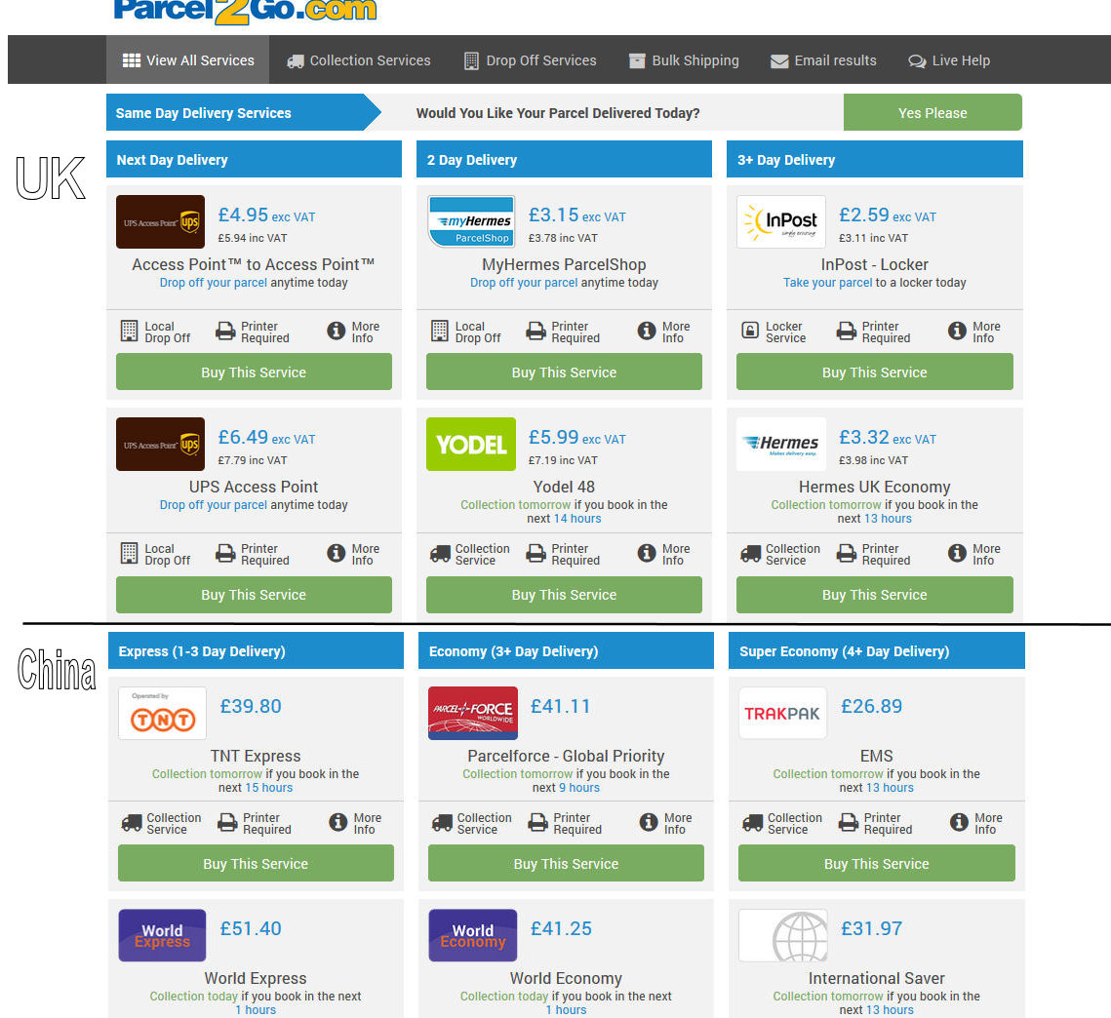
  - PayPal Fees
Ebay insist that sellers offer PayPal, even on collection only sales. A buyer may pay immediately and all you have to do is wrap up the item take to the post office and get a receipt of tracking or signed for services. You also have to assume that people use credit cards, not a debt card or PayPal balance and so incur a charge of 3.4% + 20p.
Even if posting is to a UK address the buyer’s account might be cross border and an additional charge of 0.4 to 1.5%
Fees for receiving payments from buyers outside your country, are based on the fees for receiving domestic commercial payments with the percentage based element increased by the Cross Border Fee outlined in the table below.
Sender’s Country | Cross Border Fee
Northern Europe* | 0.4%
Europe I/ US/ Canada** | 0.5%
Europe II*** | 1.0%
Rest of World | 1.5%

* Aland Islands, Denmark, Faroe Islands, Finland, Greenland, Iceland, Norway, Sweden.
** Austria, Belgium, Canada, Channel Islands, Cyprus, Estonia, France (including French Guiana, Guadeloupe, Martinique, Reunion and Mayotte) , Germany , Gibraltar, Greece, Ireland, Isle of Man, Italy, Luxembourg, Malta, Monaco, Netherlands, Portugal, Montenegro, San Marino, Slovakia, Slovenia, Spain, United Kingdom, United States, Vatican City State.
*** Andorra, Albania, Bosnia & Herzegovina, Bulgaria, Croatia, Czech Republic, Hungary, Latvia, Liechtenstein, Lithuania, Macedonia, Moldova, Poland, Romania, Russian Federation, Serbia, Switzerland, Turkey, Ukraine.

